Getting Started
Do you ever daydream and find yourself entertaining wishful thinking? There’s an old expression that goes something like, “Be careful what you wish for.”
In this project, you will read and analyze the plot of a short story that tempts a family to act on its wishful thinking. Which will win out—their caution or their desire to have their wishes fulfilled?
This short story could also be referred to as a narrative. Narrative writing is a form of storytelling. A narrative can be fiction or nonfiction. The story of a narrative builds and resolves around a sequence of events, known as a plot.
After analyzing the short story, you will develop your own narrative building together the elements of a plot to create a story.

In this project,
you will learn
to do the following:
- Write a narrative, making effective use of plot elements and mapping out elements using a graphic organizer
- Analyze a narrative for plot elements
- Deduce complex vocabulary in context and verify deductions through using a dictionary
- Write for a designated short period of time in order to make personal connections to a narrative text

Outline of Project
There are three parts to your project.
Part 1: Reading: First, you will freewrite ideas related to the short story, write answers to questions about the plot of the story, and fill in a graphic organizer mapping the plot of the narrative.
Part 2: Adaptation: Next, you will either locate an adaptation of “The Monkey’s Paw” or create one. Then you will write an essay, comparing and contrasting the original with the adaptation.
Part 3: Responding: Finally, you will outline and draft your own narrative.

Part 1: Reading
Estimated time for completion: 2 to 3 hours
Narratives tell a story. They can be nonfiction (they really happened) or fiction (they’re made up). They can be in the form of poetry, short stories, songs, or other literary forms.
In this part, you will read a narrative (a short story), write about some of the events of the story, and label the elements of the plot.
The narrative you will be reading is “The Monkey’s Paw” by W. W. Jacobs.
Before looking at this short story, read the background information on the next screen.

Background Information
The short story “The Monkey’s Paw” by W. W. Jacobs is a narrative that revolves around a plot conflict between a character and fate or the supernatural (it’s an external plot conflict).
The author, W. W. Jacobs (pictured in the photo), lived in London, England, in a house near the docks where he listened eagerly to the tales of adventure told by the sailors he met there. These tales shaped the stories he wrote as an adult—stories in which everyday life is disrupted by strange and fantastic events. “The Monkey’s Paw” is his most famous tale of the supernatural.
Beginning in the late 1700s, India became a British colony. The English East India Company settled in India in the early 1600s. They exported Indian textiles and tea. The English quickly became fascinated with Indian culture, such as the novelties of elephants, tigers, and monkeys, as well as the outrageous wealth of the rajahs and the astonishing feats of the fakirs who did things like lie on beds of nails.

Freewrite
To prepare for the reading of “The Monkey Paws,” freewrite for five minutes in response to one of the following statements (be sure to write down the statement you chose):
- One should be content with his or her life as it is.
- People should not play games with fate.
- You should never be afraid to be the master of your own destiny.
- There is no such thing as a free lunch.
Freewriting is brainstorming, which just means that you are trying to generate as much material as possible without editing yourself as you go.

Freewrite
To prepare for the reading of “The Monkey Paws,” freewrite for five minutes in response to one of the following statements (be sure to write down the statement you chose):
- One should be content with his or her life as it is.
- People should not play games with fate.
- You should never be afraid to be the master of your own destiny.
- There is no such thing as a free lunch.
Freewriting is brainstorming, which just means that you are trying to generate as much material as possible without editing yourself as you go.

Answer Questions About the Plot
Now that you have read “The Monkey’s Paw” by W. W. Jacobs, you will answer some questions about the development of the story’s plot. Answer each question with complete sentences. Write out each question, and then write the answer after the question.
Answer the following questions about the story:
- Respond: What is the most frightening moment in the story? Why?

- Recall: How does each of the Whites react when first hearing the legend of the monkey’s paw?

- Contrast: How do the reactions of the mother and father change throughout the story?

- Recall: What event fulfills Mr. White’s first wish?

- Make a Judgment: Do you think the first wish really comes true, or is there just a coincidence of events? Explain.

- Recall: How does Mr. White word his first wish?

- Infer: What painful outcome seems to follow from Mr. White’s wording of his first wish?

- Discuss: Discuss the strengths and weaknesses of other ways that Mr. White’s first wish could have been worded. Determine and explain whether or not any version is foolproof.
- Draw Conclusions: Explain whether you think the events of the story prove the fakir’s point that “fate ruled people’s lives, and that those who interfered with it did so to their sorrow.”

- What information about the paw is given in the exposition?

- Describe three events in the rising action that increase the tension in the plot.

- Where does the story reach its climax, or the most intense moment?

- Identify two details that foreshadow the tragic outcome of the first wish.
Follow your teacher’s instruction for submitting your freewriting, vocabulary words, and questions and answers.
For more information about analyzing a plot, read the information on the next screen.

How to Analyze Plot
A plot is the sequence of related events in a story. A typical plot concerns a conflict—a struggle between opposing forces. You can divide the events in the story into the five main parts of the plot. Ask yourselves these questions as you read the story:
1. Exposition—the writer gives background on the characters and situation: Which part of the story tells you who, what, where, and when?
2. Rising Action—events intensify the conflict: When do we learn what the conflict is? What events make it build in intensity?
Take notes on the five main parts of the plot.
3. Climax—the tension reaches its highest point because the outcome of the conflict is about to be revealed: What is the most exciting moment in the story? Ask yourself: Is this the point in the story when the main character wins or loses? Lives or dies?
4. Falling Action—the tension lessens because the outcome is clear: When does the conflict start to wind down after the climax?
5. Resolution—the final outcome; often, the resolution involves a change or insight: When is the conflict finally resolved? When do we learn how all the loose ends are tied up?

Create a Plot Pyramid of “The Monkey’s Paw”
Copy the plot pyramid pictured here or complete the Plot Pyramid Worksheet found in the essential documents. Fill in the blanks with corresponding details from “The Monkey’s Paw.”
Follow your teacher’s instruction for submitting your work.

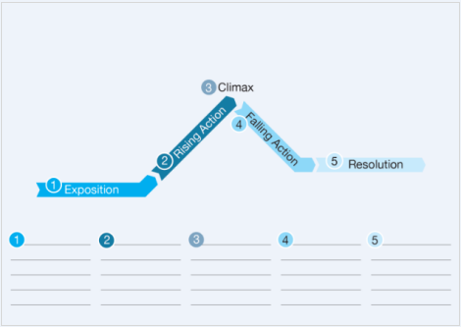

Part 2: Adaptation
Estimated time for completion: 2 to 3 hours
Many people might use “The Monkey’s Paw” as an inspiration or basis for another form of artistic expression, like creating a film of the story, an audio version, a poem, or a song.
Search the Internet for adaptations of the short story and pick one.
If you cannot find an adaptation, then you can create your own. It can be a drawing, alternative ending to the short story, a narrative poem, a song, an epistolary writing capturing the story in a letter from a character telling the story of the Whites, a dramatic monologue from the short story, a graphic novel, or some other artistic form of expression.
If you write an adaptation, choose the rubric corresponding with your type of piece, Narrative Rubric, Alternate Ending to a Narrative Rubric, Narrative Poem Rubric, Song Lyrics Rubric, or Epistolary Novel Rubric found in the essential documents to evaluate your work. If you chose a different kind of artistic expression, then use the rubric that you think best matches your work.

Write three or four paragraphs comparing and contrasting the adaptation to the original short story.
Use the Comparison-and-Contrast Essay Rubric found in the essential documents to help you evaluate your work.
Submit your comparison-and-contrast essay to your teacher. Also, if you created an adaptation of the short story, submit it to your teacher. Follow your teacher’s instruction for submitting your work.

Part 3: Responding
Estimated time for completion: 3 to 4 hours
Now you will write your own narrative. You will create your own story. You can write a sequel to “The Monkey’s Paw” or use your imagination to create your own scenes and events.
Before you get started on your story, read the tips about writing a narrative beginning on the next screen.
Take notes about writing a narrative on the following screen.
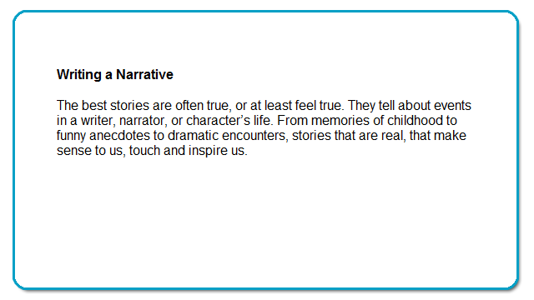
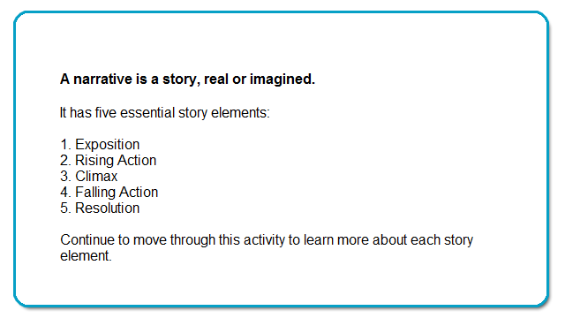
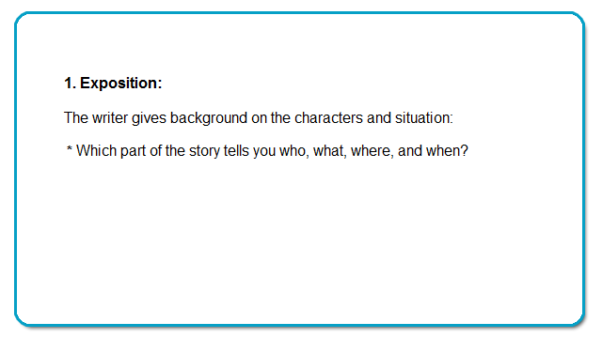
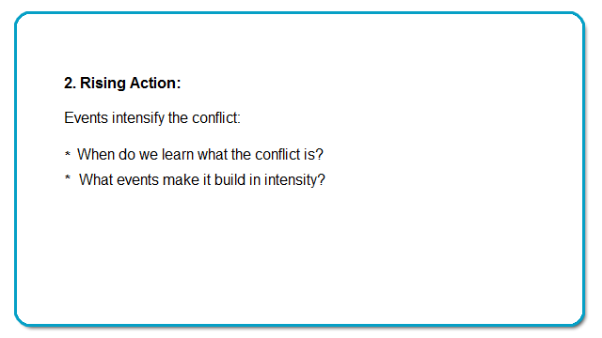
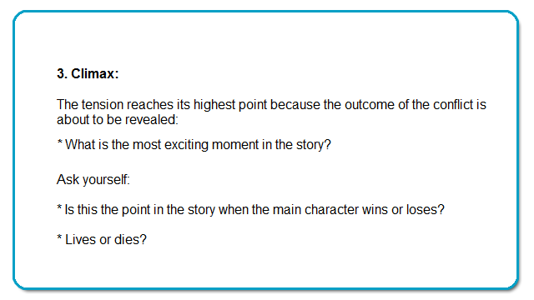
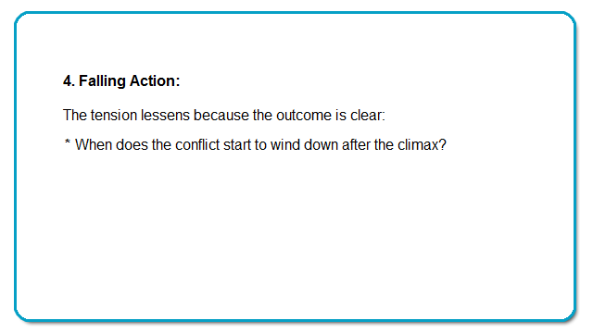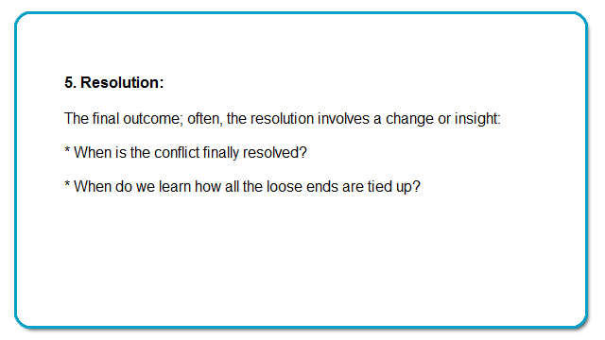
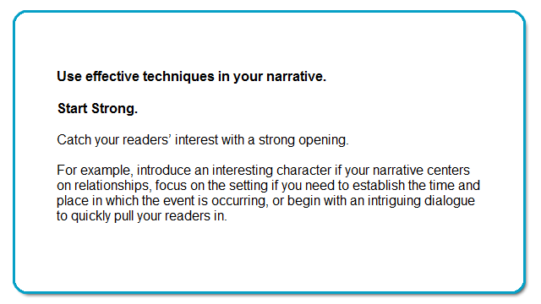
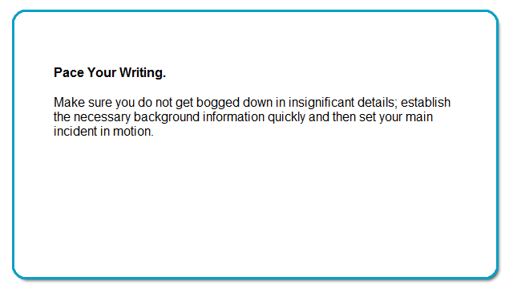
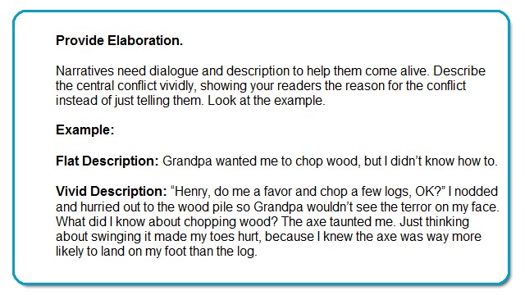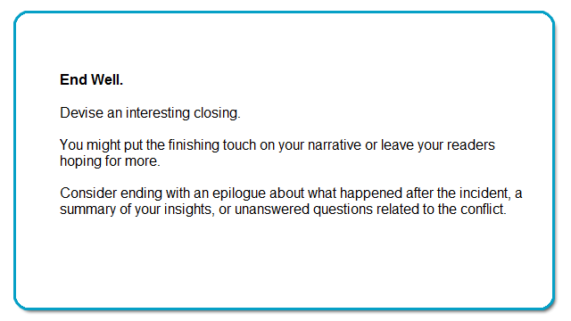

Choose a Topic for Your Narrative
Choose one of the following topics for your narrative:
- Write a sequel to “The Monkey’s Paw.”
- Write about wishful thinking.
- Write about living your favorite song.
- Write about art.
- Write around a historical event.
- Apply your narrative writing to a real-life situation; for example, write a narrative for a college application.

opic Descriptions
Here are some possible topic descriptions for you to work with to draft your narrative:
Wishful Thinking—
“The Monkey’s Paw” was about wishful thinking. What kinds of things do you wish for? If you could have a wish come true, what would your life look like? Write a narrative around one of these wishes.
Living Your Favorite Song—
List five of your favorite songs. Write down the places and people you associate with the songs. Pick one. Write a few sentences explaining why this is your favorite. Visualize the first time you heard the song and when that song became significant to you. Now write a narrative using the song as your basis. Make sure the narrative contains the basic plot elements.
A Sequel to “The Monkey’s Paw”—
For a possible sequel, you could claim that the son’s death and the knocking were merely coincidences or that the soldier never really made a wish—he just said he did to build curiosity about the paw or to avoid admitting that he was scared of it; consequently, when someone else finds the monkey’s paw, there are still three wishes left.
A Historical Event—
Think of a moment of great historical importance, either in the near or distant past, one that captures your imagination. Imagine a story in which characters find themselves in this moment in time. What happens to them?
Real Life: A College Application—
Many college applications ask a student to write an essay about topics that lend themselves to narratives, such as an important moment in the student’s life, a hobby or interest, the reason for choosing his or her major. Find out what the essay topic is for a college application that you are interested in filling out. Write a narrative that could be included as part of this college application.


Narrow Your Topic and Create a Plot Pyramid
Keep your narrative limited to an appropriate scope. Focus on one brief moment or event in time, so that you can fully capture it in four or five pages, including room for dialogue.
Create a Plot Pyramid
Before you begin writing, fill in a plot pyramid to outline your narrative. You will submit your plot pyramid to your teacher with your narrative.
Copy the plot pyramid pictured here or complete the Plot Pyramid Worksheet found in the essential documents. Fill in the blanks with details or events and other aspects of the plot that you will develop in your narrative.

Write Your Narrative
Write a four-or-five page narrative. In your narrative, be sure to:
- Title your story.
- Include and write about the events for the five parts or elements of a plot that you outlined in your plot pyramid.
- Build a sequence of events—building one upon another.
- Show, don’t tell, the reader your story:
o Use sensory language (appeal to the five senses—see, taste, sound, touch, and smell).
o Use imagery.
o Use dialogue to advance the plot.
To be effective, your narrative should include the following elements:
- A clear sequence of events
- A pace that effectively builds the action
- Specific details and quotations that help readers vividly imagine movement, gestures, and expressions
- Error-free writing, including correct use of complete sentences
Use the Narrative Rubric found in the essential documents to help you evaluate your work.
To learn about using dialogue or sensory language, read the tips beginning on the next screen.

How to Use Sensory Language
Move through the activity to learn how to use sensory language.
Copy the information into your notes.

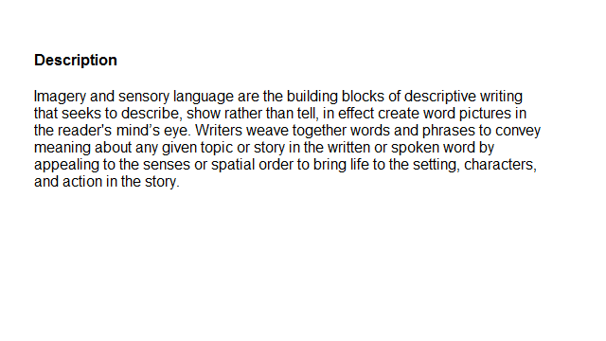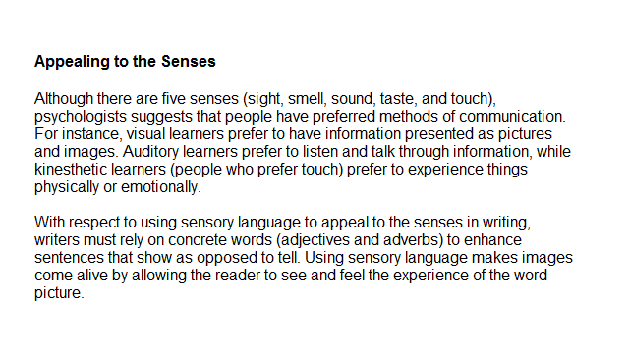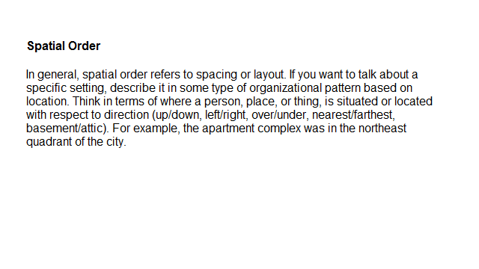How to Use Dialogue
Move through the activity to learn how to use dialogue in your writing.
Copy the information into your notes.
